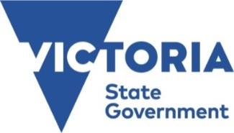
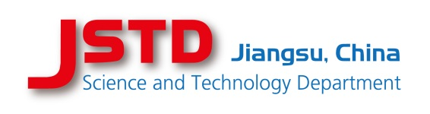
Jiangsu Science and Technology Department

Department of Jobs, Precincts and Regions

Victoria - Jiangsu Program for Technology and Innovation R&D
(VIC-JS TECH)

Third Call for proposals for joint commercially focussed R&D

The government of Jiangsu Province, the People's Republic of China and the government of Victoria, Australia signed a bilateral agreement in October 2019 to continue a framework program for commercially focussed, technology and innovation research and development (R&D) with the aim of supporting joint industrial R&D projects to develop products or processes for commercialisation in the global market.

To further the aims of the bilateral agreement, a grant program (VIC-JS TECH) will enable entities to seek support for joint R&D projects involving at least one Victorian partner and one Jiangsu company.

The bilateral grant program is implemented by the Jiangsu Science and Technology Department in Jiangsu Province and the Department of Jobs, Precincts and Regions in Victoria. Funding will be granted according to both countries’ usual funding principles.

Preferred technology sectors
This call for proposals is open for joint projects in the preferred areas of:

- Biotechnology, New Medicine and Medical Devices
- New Generation Information and Communication Technology
- Clean Technology and Environmental Protection
- Food and Fibre Industries
- Advanced Manufacturing and Aerospace Industries

Other areas that are mutually accepted will also be considered.

Project structure and support
- The project must involve at least one Jiangsu and one Victorian partner.
- The project should demonstrate equal contributions by both parties and equal benefit derived by both parties.
- The project must involve highly innovative, market-oriented, development of a new product or process.
- Funding support will be provided to each partner by its own implementing organisation.
- Funding support will not exceed 50% of the eligible approved project costs.
- The approval of the funding will be made jointly by both implementing organisations.
Applications
This call for proposals will follow a two-stage application procedure:

1. An expression of interest including a bilateral cooperation form should be submitted to both jurisdictions at the same time.

2. Eligible projects will be invited to submit a full application online to the respective implementing organisation according to its own rules and procedures.

Expressions of interest should be submitted from 27th November 2019 to 19th February 2020.

Eligibility
In Jiangsu
Eligible applicants will be R&D performing registered companies operating in Jiangsu.

In Victoria
An eligible applicant will be a R&D performing company (including research entities - independent institute or university) that has its registered office and principal place of business located in Victoria.

Further information
For further information contact:

In Jiangsu
Ms Guo Hong
Jiangsu Science and Technology Department
Tel: 0086-25-57713559
Email: guoh@jstd.gov.cn

In Victoria
Mr Simon Rabl
DJPR
Tel: +61 396519125
Email: simon.rabl@ecodev.vic.gov.au

